Arabic Sign Language

Computer Vision- University of Nebraska-Lincoln

Contents

Abstract 3

Introduction 4

Methodology 4

Results 5

Future Work 7

Conclusion 8

References 8

Abstract:

Detect and recognize Arabic sign language (ArSL) for the deaf and hard-of-hearing communities in Arabic-speaking regions. This project aims to develop a preprocessing pipeline for ArSL gesture recognition by focusing on efficient hand detection and image cropping. Using MediaPipe, a state-of-the-art hand-tracking framework, the system extracts hand regions from gesture images, preparing them for further classification. The dataset is processed to ensure high-quality cropped hand images, overcoming challenges like missed detections and noisy backgrounds. This project establishes a strong foundation for future work in gesture classification and real-time ArSL recognition.

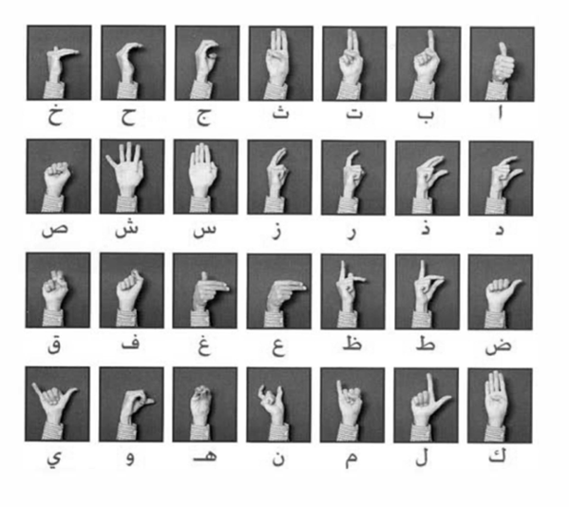
Figure 1: Arabic Sign Language Letter

Introduction:

Arabic Sign Language (ArSL) is a vital communication medium for individuals with hearing and speech impairments in Arabic-speaking communities. The goal of this project is to leverage computer vision techniques to develop a system capable of detecting and recognizing ArSL gestures. By focusing on hand detection and gesture preprocessing, this project lays the foundation for building robust ArSL recognition models.

The results of our work on detecting and preparing hand images are from an ArSL dataset. The project combines machine learning techniques with advanced image processing tools to achieve effective hand detection and cropping. The core objective is to accurately detect and crop hands from gesture images, which is a critical preprocessing step for building automated sign language recognition systems. By leveraging MediaPipe, a cutting-edge hand detection framework, we ensure efficient and precise extraction of hand regions, even in challenging scenarios involving complex backgrounds or occlusions. We aim to contribute to the broader vision of making technology accessible and empowering individuals with hearing and speech impairments. By addressing the unique challenges of Arabic Sign Language, this work is a step toward creating inclusive solutions for underrepresented languages and communities.

Methodology:
The project employs a two-step approach: detecting hands in images and preparing cropped regions for further analysis.
3.1 Hand Detection:
The MediaPipe Hands module was employed for detecting hands in images. MediaPipe uses a pre- trained model for identifying hand landmarks and estimating bounding boxes around detected hands.
3.2 Cropping with MediaPipe:
A custom function, detect_and_crop_hand_mediapipe, performs the following:
- Reads and converts the image to RGB.
- Detects hands using MediaPipe's pre-trained hand landmark model.
- Computes a bounding box around the detected hand with optional padding.
- Crops the hand region and converts it back to an RGB format for visualization.

Results:

Total Images Processed: 14,202

Total hands successfully cropped: 13,317

Total hands missed: 885

The model achieved 92.57% as a validation accuracy and the loss was only 0.2233, which indicates how well the model generalizes to unseen data after training.

Visualization:

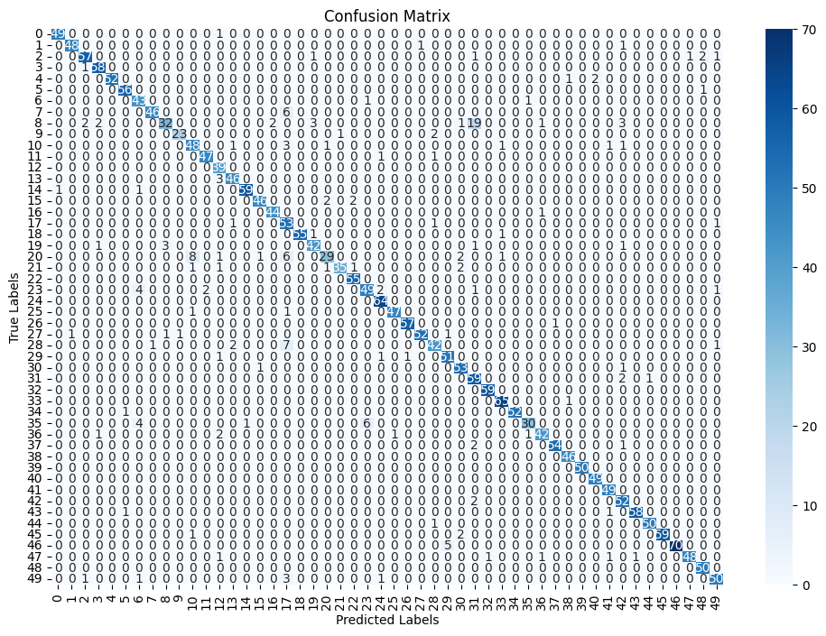
Figure 2: Confusion Matrix

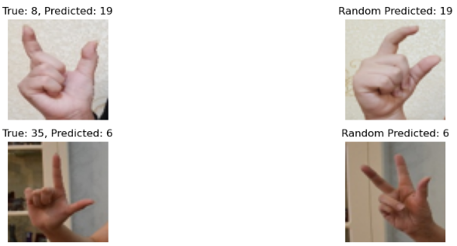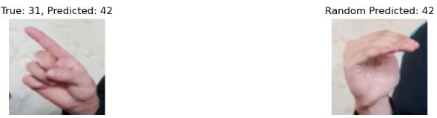

The confusion analysis highlights the model's performance on misclassified images. We identified the top 3 cases where the model's predictions differed from the true labels and visualized these alongside random images from the predicted labels. This approach demonstrates how visual similarities between classes may lead to confusion. For instance, the misclassified images share common features with the predicted label, suggesting that the model struggles with distinguishing these patterns. Additionally, we presented corresponding predicted label images to validate the visual similarity hypothesis.

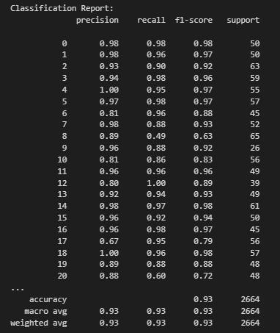
Figure 3: Evaluation Matrix

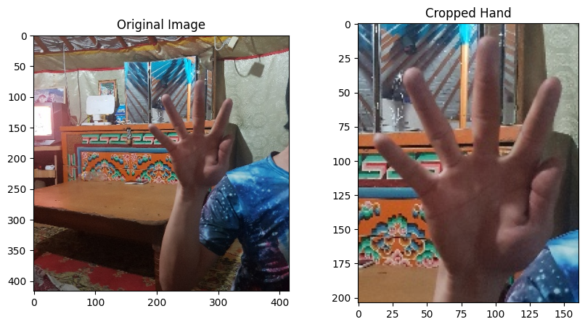
Figure 4: Original Vs Cropped Image

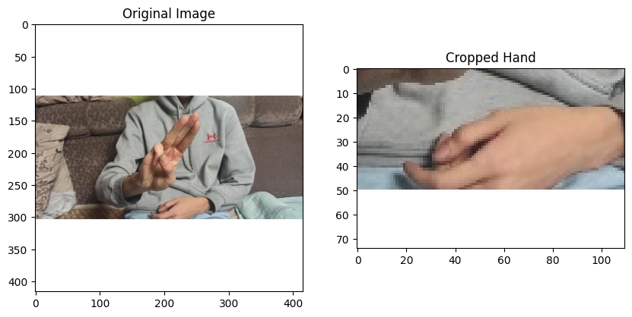
Figure 5: Sample miss cropped image

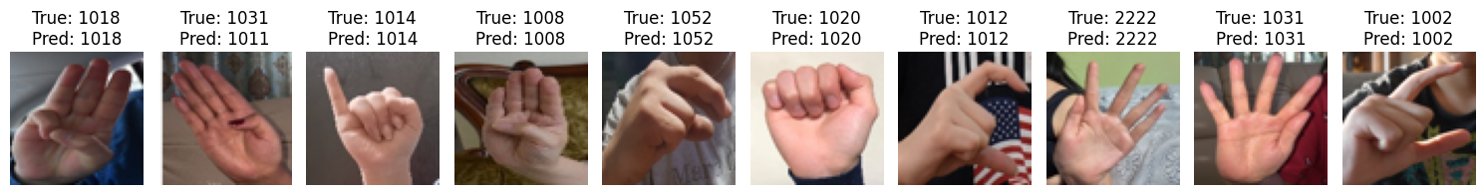
Figure 6: Sample predictions

Future Work:
- Data Augmentation:
Enhance the dataset using techniques like rotation, scaling, and flipping.
- Real-Time Applications:
Extend the project to recognize gestures in real-time using live video feeds.

Model Fine-Tuning with YOLOv5:
Use You Only Look Once to have better performance.

Conclusion:

This project successfully developed a preprocessing pipeline for Arabic Sign Language (ArSL) recognition, focusing on efficient hand detection and image cropping. Utilizing MediaPipe’s cutting-edge hand detection framework, the system demonstrated strong performance, with over 92% of the images processed successfully and a validation accuracy of 92.57%. These results highlight the system’s reliability in extracting high-quality hand regions, overcoming challenges such as complex backgrounds and missed detections.

This project underscores the importance of leveraging computer vision to create inclusive solutions that empower diverse communities and expand the reach of assistive technologies.

References:

Kaggle Dataset: https://www.kaggle.com/datasets/ammarsayedtaha/arabic-sign-language-dataset-2022?resource=download

